**Assigment 1**

**Name: Omerullah Ansari**

**ID: 65584**

Q1

def findComplement(n):

if n == 0:

return 1

binaryRep = bin(n)[2:]

flippedBinaryRep = ''.join('1' if bit == '0' else '0' for bit in binaryRep)

complement = int(flippedBinaryRep, 2)

return complement

print(findComplement(5))

print(findComplement(0))

print(findComplement(1))

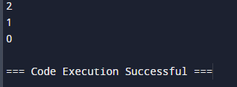

Q2

def countingSort(arr):

max_val = max(arr)

count = [0] * (max_val + 1)

while len(arr) > 0:

num = arr.pop(0)

count[num] += 1

for i in range(len(count)):

while count[i] > 0:

arr.append(i)

count[i] -= 1

return arr

unsortedArr = [0, 1, 0, 1, 0, 0, 1, 1, 1, 0]

sortedArr = countingSort(unsortedArr)

print("Sorted array:", sortedArr)

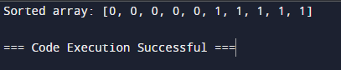

Q3

def bubbleSortStrings(arr):

n = len(arr)

for i in range(n):

for j in range(0, n - i - 1):

if arr[j] > arr[j + 1]:

arr[j], arr[j + 1] = arr[j + 1], arr[j]

arr = ["banana", "apple", "cherry", "date"]

bubble_sort_strings(arr)

print("Sorted array is:", arr)

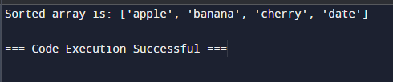

Q4

def findMissingNumbers(arr, low, high):

arr_set = set(arr)

missingNumbers = []

for num in range(low, high + 1):

if num not in arr_set:

missingNumbers.append(num)

return missingNumbers

arr = [1, 3, 5, 7, 9]

low = 4

high = 10

missingNumbers = findMissingNumbers(arr, low, high)

print(missingNumbers)

